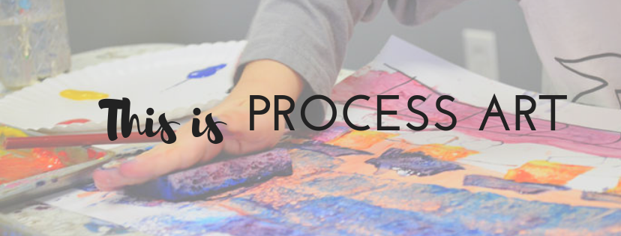

The Role of Process Art in (INSERT YOUR NAME HERE)’s Classroom

Hey parents, I’m looking forward to amazing school year with your children. A big part of the learning that takes place in our class every single day is through the art that we make. We are a PROCESS ART classroom, which means when we are doing an art activity, our focus is on the learning that takes place through the manipulation of art supplies and art concepts--rather than the end project. Which means, you may take home beautifully painted pictures. Or you may get brown globs of goo.

What We’re Learning When We’re Making Art

*We are learning SO MUCH when we’re manipulating mark-making materials (that’s pencils, markers, crayons, paintbrushes, oil pastels, chalk, etc).*

* Physically, we’re working our little tiny finger muscles…those fine motor skills that we’re going to need in Kindergarten when we’re expected to be able to form letters and write legibly.
* We’re also exercise our focus and attentiveness. Did you know that attentiveness is a SKILL that we can practice and get better at? In the fast-moving-digital, instant-gratification, flashy world that we live it, we need all the practice we can get.
* If we’re engrossed in simply the FEEL of the paint on our fingers, the SOUND of the chalk on the paper, or the SIGHT of the paint changing colors…our bodies are receiving necessary sensory input. Sensory needs create calm within our bodies so that we can use our brain to learn many other things.
* When we’re making ART (not craft), we’re learning to take ideas that our in our brains and put them on paper in a way that can be understood by others. This type of imaginative drawing is a cognitive skill and is a pre-writing skill.

