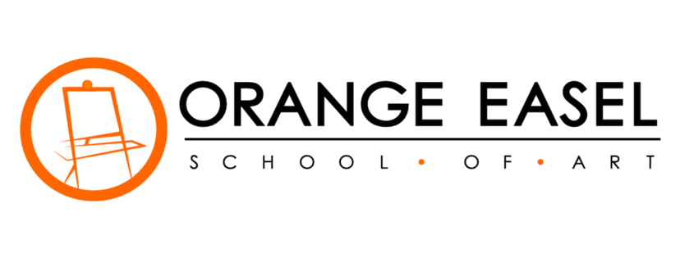
30 Wake-Up Art Invitations For Screen-Free Mornings | 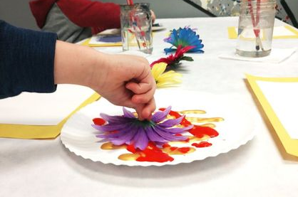
 | Flower Painting – Day 12
1 | 2 | 3 | 4 | 5 | 6 | 7
Pointillism Art | Nature Critters | Recycled Tin Can Windsocks | Hot Crayon Rocks | Eye Of God | Kinetic Sand Slime | Paper Pinwheels
8 | 9 | 10 | 11 | 12 | 13 | 14
Shaving Cream Marbled Paper | Three Ingredient Play Dough | Faux Stained Glass Artwork | Milk Jug Watering Can | Flower Painting | Invisible Ink | Magazine Art
15 | 16 | 17 | 18 | 19 | 20 | 21
Make An Easy Lava Lamp | Rainbow Bubbles | Funny Face Flip Book | Dustless Sidewalk Chalk | Bubble Snakes | Miniature Clay Unicorns | Ice Chalk
22 | 23 | 24 | 25 | 26 | 27 | 28
Yarn-Bombed Butterflies | Jumping Origami Frogs | 3D Bubble Wands | Temporary Tattoo Kid Art | Paper Bead Necklaces | Mini Colored Kitchen Volcanoes | Fairy Bells
29 | 30
Toy Parachute Craft | Fireworks In A Glass

Orange Easel School of Art  249 W Mill St Ste 107  Liberty MO 64068  artclasses@orangeeaselart.com  816-407-9266 | For great Orange Easel merchandise, visit us at: https://orange-easel.myshopify.com/ | DO  ART BETTER

